Education and Care First Aid with Asthma and Anaphylaxis

This course is specifically designed to meet the needs of educators and support staff working within an education and care setting, who are required to respond to a first aid emergency including asthmatic and anaphylactic emergencies. This course is a nationally recognised unit that describes the skills and knowledge required to provide a first aid response to infants, children, and adults. It covers child-specific first aid in many high-risk areas such as anaphylaxis and asthma, as well as common injuries and resuscitation.
This course has been approved by the Australian Children’s Education and Care Quality Authority and also satisfies all requirements for first aid, anaphylaxis management, and emergency asthma training under the Education and Care Service National Law and the Education and Care Services National Regulations (2011).
COURSE DURATION
St John offers the following options:
- 2 days (face to face workshops with prework): This is face to face course and with online prework. Participants are required to undertake online e-learning module prior to attending the face to face workshops for practice and assessment.
- Assessment only: This course is for those who are confident in their skills and only want to complete the assessment.
CERTIFICATE
On successful completion of this course you will be issued a statement of attainment in:
- HLTAID004 Provide First Aid in an education and care setting
- HLTAID003 Provide First Aid
- HLTAI002Provide Basic Emergency First Aid
- HLTAID001 Provide cardiopulmonary resuscitation
- 22300VIC Course in First Aid Management of Anaphylaxis
- 22556VIC Course in the Management of Asthma Risks and Emergencies in the workplace
St John recommends, as per the First Aid in the Workplace Code of Practice and the Australian Resuscitation Council guidelines, that first aid skills are renewed every 3 years and resuscitation skills (HLTAID001/HLTAID0007) are renewed every 12 months.
Refresher training is also recommended every three (3) years according to Victorian Ministerial Order 706 and/or as per the relevant State/Territory legislation and workplace requirement. The existing course meets the needs of each of the following legislation and it is anticipated that the re-accredited course will meet these requirements:
- Ministerial Order 706 - Anaphylaxis Management in Victorian Schools
- Children’s Services Regulations 2009
- Education and Care Services National Regulations 2011
COURSE OUTLINE
This course covers the following:
- Regulations and definitions of asthma and anaphylaxis  - CPR techniques on infants, children, and adults  - DRSABCD, including the trained use of a defibrillator  - Incident reporting in a childcare setting  - Using AED’s on adults and children  - Anaphylaxis Management for children and adults  - Emergency Asthma Training for children and adults | - Managing shock, seizures, bites, stings  - How to properly assess an emergency  - First Aid procedures for bleeding, burns and fractures  - Managing medical conditions such as epilepsy  - Infection control procedures  - Legal responsibilities of a First Aider  - Safety and risk management
ASSESSMENT METHODS
A successful outcome for this statement of attainment will be determined by a range of different methods including written assessment, observation of simulated and practical activities etc.
You will be required to demonstrate CPR on a manikin on the floor.
LOCATIONS
St John delivers first aid courses nationally and across many locations in Australia. Choose the location to suit your needs.
- PUBLIC (at a venue near you)
- CUSTOMISED (on-site consultation)
- ONSITE (at a venue of your choice)
- ONLINE (training delivered online from our e-Learning platform)
DELIVERY BY ST JOHN’S RTO PARTNERS
St John Ambulance Australia’s courses are delivered by way of partnership agreements (e.g. with State or Territory St John Ambulance organisations). Our partners are authorised to deliver training on behalf of St John Ambulance Australia Ltd. (TOID 88041). Contact details for our partner organisations are available from www.stjohn.org.au or call 1300 ST JOHN.
PARTICIPANT’S HANDBOOK
Download the Participant’s Handbook from www.stjohn.org.au for more information about completing a course with St John Ambulance Australia. This includes information about complaints, appeals and privacy information.
We actively tailor training to meet the needs of people from diverse backgrounds and abilities and encourage all to apply.
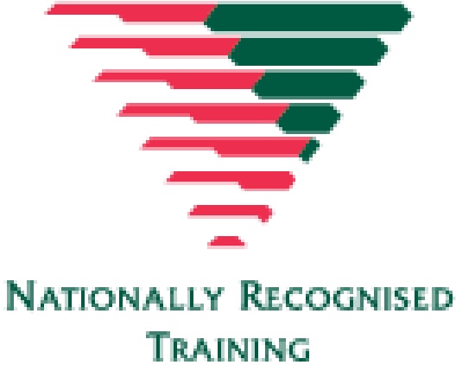
For more information on this course,
contact the Training Office in your area
1300 ST JOHN (1300 785 646) WWW.STJOHN.ORG.AU

