Remote area first aid

This remote area first aid course is specifically designed to meet the first aid needs of bushwalkers, wilderness guides, and people who work or live in remote locations.
The course covers everything from comprehensive first aid treatments to aeromedical evacuation, long-term care, self-care, and contingency planning. This course is focused on the safety of the first aider and extended care of an ill or injured casualty where help is likely to be delayed or inaccessible.
COURSE DURATION
St John offers the following options:
- 4 days face to face workshop: This is full face to face course and participants are required to attend both the days. Participants who have completed HLTAID011 Provide first aid in last months may be entitled to an exemption from the first two days.
- 3 days (face to face workshops with pre-work): Participants are required to undertake online e-learning module prior to attending the face to face workshops for practice and assessment. Participants who have completed HLTAID011 Provide first aid in last 12 months may be entitled to an exemption from the first day.
- Assessment only: This course is for those who are confident in their skills and only want to complete the assessment.
CERTIFICATE
On successful completion of this course you will be issued a statement of attainment in:
- HLTAID013 Provide First Aid in remote and isolated sites
St John recommends, as per the First Aid in the Workplace Code of Practice and the Australian Resuscitation Council guidelines, that first aid skills are renewed every 3 years and resuscitation skills (HLTAID009/HLTAID0015) are renewed every 12 months.
COURSE OUTLINE
The course covers the following: ‘
- Infection control  - DRSABCD action plan  - Managing the unconscious breathing casualty  - Resuscitation and Defibrillation  - Choking, chest pain, stroke, shock  - Asthma, allergic reactions and Anaphylaxis  - Burns, wounds and bleeding  - Fractures & dislocations / sprains & strains  - Head, neck & spinal injuries  - Facial & eye injuries | - Hyperthermia and hypothermia  - Rescue preparation and evacuation  - Poisons, bites, and stings  - Diabetes and seizures  - Remote area first aid  - Two-rescuer resuscitation  - Planning, preparation, and communication  - Triage, advanced bleeding  - Managing environment-induced illness’  - Lifting and moving casualty

ASSESSMENT METHODS
A successful outcome for this statement of attainment will be determined by a range of different methods including written assessment, observation of simulated and practical activities etc.
You will be required to demonstrate CPR on a manikin on the floor.
LOCATIONS
St John delivers first aid courses nationally and across many locations in Australia. Choose the location to suit your needs.
- PUBLIC (at a venue near you)
- CUSTOMISED (on-site consultation)
- ONSITE (at a venue of your choice)
- ONLINE (training delivered online from our e-Learning platform)
DELIVERY BY ST JOHN’S RTO PARTNERS
St John Ambulance Australia’s courses are delivered by way of partnership agreements (e.g. with State or Territory St John Ambulance organisations). Our partners are authorised to deliver training on behalf of St John Ambulance Australia Ltd. (TOID 88041). Contact details for our partner organisations are available from www.stjohn.org.au or call 1300 ST JOHN.
PARTICIPANT’S HANDBOOK
Download the Participant’s Handbook from www.stjohn.org.au for more information about completing a course with St John Ambulance Australia. This includes information about complaints, appeals and privacy information.
We actively tailor training to meet the needs of people from diverse backgrounds and abilities and encourage all to apply.
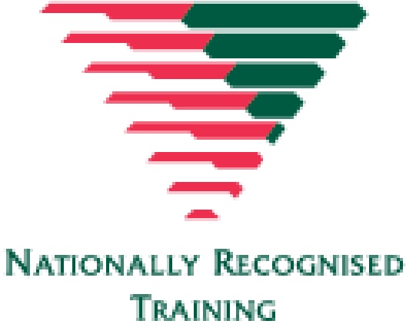
For more information on this course,
contact the Training Office in your area
1300 ST JOHN (1300 785 646) WWW.STJOHN.ORG.AU

