Provide First aid

The flagship St John Ambulance first aid course covers a comprehensive range of topics to enable participants to confidently manage emergency situations and provide a first aid response to a casualty. It covers the most common first aid injuries and illnesses.
It is suitable for both people in the workplace and members of the public who want training in first aid.
COURSE DURATION
St John offers the following options:
- 2 days face to face workshop: This is full face to face course and participants are required to attend both the days.
- 1 day (face to face workshops with pre-work): Participants are required to undertake online e-learning module prior to attending the face to face workshops for practice and assessment.
- Assessment only: This course is for those who are confident in their skills and only want to complete the assessment.
CERTIFICATE
On successful completion of this course you will be issued a statement of attainment in:
- HLTAID009 Provide cardiopulmonary resuscitation
- HLTAID010 Provide basic emergency life support
- HLTAID011 Provide First Aid
St John recommends, as per the First Aid in the Workplace Code of Practice and the Australian Resuscitation Council guidelines, that first aid skills are renewed every 3 years and resuscitation skills (HLTAID009/HLTAID0015) are renewed every 12 months.
COURSE OUTLINE
The course covers the following:
- Roles and responsibilities of the first aider  - The DRSABCD action plan and responding to emergency situations  - Managing unconscious casualties  - Cardiopulmonary resuscitation (CPR)  - Using a defibrillator (AED)  - Legal issues in first aid  - Infection control  - Diabetes and seizures  - Asthma  - Allergic reactions and Anaphylaxis  - Wound and bleeding management | - Burns  - Fractures and dislocations  - Sprains and strains  - Hypothermia and hyperthermia  - Head, neck, and spinal injuries  - Medical emergencies  - Choking  - Abdominal and chest injuries  - Poisoning management  - Bites and stings  - Stroke  - Safety and risk management
ASSESSMENT METHODS
A successful outcome for this statement of attainment will be determined by a range of different methods including written assessment, observation of simulated and practical activities etc.
You will be required to demonstrate CPR on a manikin on the floor.
LOCATIONS
St John delivers first aid courses nationally and across many locations in Australia. Choose the location to suit your needs.
- PUBLIC (at a venue near you)
- CUSTOMISED (on-site consultation)
- ONSITE (at a venue of your choice)
- ONLINE (training delivered online from our e-Learning platform)
DELIVERY BY ST JOHN’S RTO PARTNERS
St John Ambulance Australia’s courses are delivered by way of partnership agreements (e.g. with State or Territory St John Ambulance organisations). Our partners are authorised to deliver training on behalf of St John Ambulance Australia Ltd. (TOID 88041). Contact details for our partner organisations are available from www.stjohn.org.au or call 1300 ST JOHN.
PARTICIPANT’S HANDBOOK
Download the Participant’s Handbook from www.stjohn.org.au for more information about completing a course with St John Ambulance Australia. This includes information about complaints, appeals and privacy information.
We actively tailor training to meet the needs of people from diverse backgrounds and abilities and encourage all to apply.
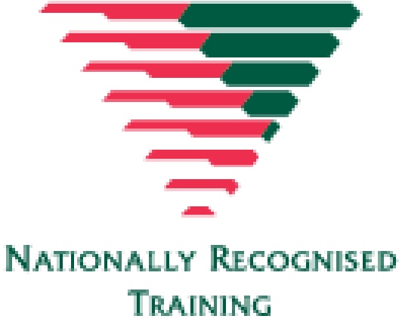
For more information on this course,
contact the Training Office in your area
1300 ST JOHN (1300 785 646) WWW.STJOHN.ORG.AU

