Asthma in the workplace

The course gives you the confidence, knowledge, and skills to recognise and manage an asthmatic emergency including the use of the asthma inhaler. This course will provide participants with the knowledge and skills to be able to develop an asthma management strategy and provide asthma related first aid interventions in the workplace.
PRE-REQUISITE UNIT
There are no entry requirements or prerequisites to undertake this training however it is recommended that students have current CPR training as well.
COURSE DURATION
St John offers the following options:
- 4 hours face to face workshop: This is full face to face course and participants are required to attend the full workshop.
- Assessment only: Assessment only: This course is for those who are confident in their skills and only want to complete the assessment.
CERTIFICATE
On successful completion of this course you will be issued a statement of attainment in:
- 22556VIC Course in the Management of Asthma Risks and Emergencies in the Workplace
St John recommends, refresher training every three (3) years according to Victorian Ministerial Order 706 and/or as per the relevant State/Territory legislation and workplace requirement. The existing course meets the needs of each of the following legislation and it is anticipated that the re-accredited course will meet these requirements:
- Ministerial Order 706 - Anaphylaxis Management in Victorian Schools
- Children’s Services Regulations 2009
- Education and Care Services National Regulations 2011
COURSE OUTLINE
This course covers the following:
- Asthma signs, symptoms, and triggers
- Asthma medications and devices
- Asthma action plans
- Asthma risk management planning for the workplace
- Hands-on-practice in using Asthma inhalers
- Asthma first aid management

ASSESSMENT METHODS
A successful outcome for this statement of attainment will be determined by a range of different methods including written assessment, observation of simulated and practical activities etc.
LOCATIONS
St John delivers first aid courses nationally and across many locations in Australia. Choose the location to suit your needs.
- PUBLIC (at a venue near you)
- CUSTOMISED (on-site consultation)
- ONSITE (at a venue of your choice)
- ONLINE (training delivered online from our e-Learning platform)
DELIVERY BY ST JOHN’S RTO PARTNERS
St John Ambulance Australia’s courses are delivered by way of partnership agreements (e.g. with State or Territory St John Ambulance organisations). Our partners are authorised to deliver training on behalf of St John Ambulance Australia Ltd. (TOID 88041). Contact details for our partner organisations are available from www.stjohn.org.au or call 1300 ST JOHN.
PARTICIPANT’S HANDBOOK
Download the Participant’s Handbook from www.stjohn.org.au for more information about completing a course with St John Ambulance Australia. This includes information about complaints, appeals and privacy information.
We actively tailor training to meet the needs of people from diverse backgrounds and abilities and encourage all to apply.
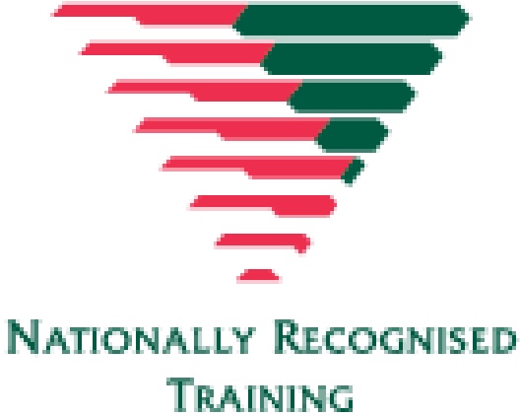
For more information on this course,
contact the Training Office in your area
1300 ST JOHN (1300 785 646) WWW.STJOHN.ORG.AU

