Provide advanced resuscitation

The St John Advanced Resuscitation course is a course designed for experienced first aiders who use specific equipment and often work in higher risk environments. This course develops advanced skills for providing life support and focuses on the use of oxygen delivery systems and in-depth knowledge and skill in the use of Automated External Defibrillators (AED). This course also covers the skills and knowledge required to use specialised equipment in the provision of resuscitation and oxygen therapy in line with the Australian Resuscitation Council (ARC) guidelines.
PRE-REQUISITE UNIT
Participants are required to undertake or present evidence for HLTAID011 Provide First Aid prior to commencing HLTAID015 Provide advanced resuscitation and oxygen therapy.
COURSE DURATION
St John offers the following options:
- 1 day face to face workshop: This is full face to face course and participants are required to attend the full day.
- 5 hours (face to face workshops with pre-work): Participants are required to undertake online e-learning module prior to attending the face to face workshop for practice and assessment.
- Assessment only: This course is for those who are confident in their skills and only want to complete the assessment.
CERTIFICATE
On successful completion of this course you will be issued a statement of attainment in:
- HLTAID009 Provide cardiopulmonary resuscitation
- HLTAID015 Provide advanced resuscitation and oxygen therapy
St John recommends, as per the First Aid in the Workplace Code of Practice and the Australian Resuscitation Council guidelines, that first aid skills are renewed every 3 years and resuscitation skills (HLTAID009/ HLTAID015) are renewed every 12 months.
COURSE OUTLINE
This course covers
- DRSABCD action plan  - Infection control  - Automated External Defibrillation (AED)  - Soft bag resuscitation  - Administration of oxygen  - Oxygen delivery systems  - Oxygen therapy and resuscitation  - Oropharyngeal airway | - Bag valve mask (BVM)  - Legal and other requirements  - Cardiopulmonary resuscitation  - Anatomy and physiology  - Assessment of vital signs  - Levels of consciousness  - Suction equipment  - Maintenance of resuscitation equipment

ASSESSMENT METHODS
A successful outcome for this statement of attainment will be determined by a range of different methods including written assessment, observation of simulated and practical activities etc.
You will be required to demonstrate CPR on a manikin on the floor.
LOCATIONS
St John delivers first aid courses nationally and across many locations in Australia. Choose the location to suit your needs.
- PUBLIC (at a venue near you)
- CUSTOMISED (on-site consultation)
- ONSITE (at a venue of your choice)
- ONLINE (training delivered online from our e-Learning platform)
DELIVERY BY ST JOHN’S RTO PARTNERS
St John Ambulance Australia’s courses are delivered by way of partnership agreements (e.g. with State or Territory St John Ambulance organisations). Our partners are authorised to deliver training on behalf of St John Ambulance Australia Ltd. (TOID 88041). Contact details for our partner organisations are available from www.stjohn.org.au or call 1300 ST JOHN.
PARTICIPANT’S HANDBOOK
Download the Participant’s Handbook from www.stjohn.org.au for more information about completing a course with St John Ambulance Australia. This includes information about complaints, appeals and privacy information.
We actively tailor training to meet the needs of people from diverse backgrounds and abilities and encourage all to apply.
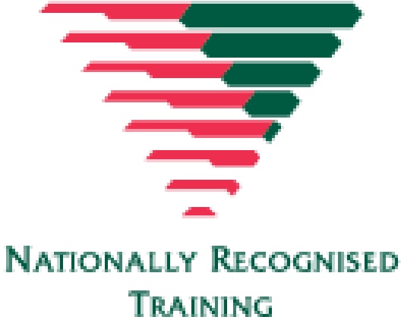
For more information on this course,
contact the Training Office in your area
1300 ST JOHN (1300 785 646) WWW.STJOHN.ORG.AU

