Education and Care First Aid with PFA

This course specifically designed to meet the needs of people working in the childcare and early childhood learning industry. It is tailored towards anyone working with children. It covers child-specific first aid in high-risk conditions such as anaphylaxis and asthma, and common injuries and resuscitation.
COURSE DURATION
St John offers the following options:
- 2 day (face to face workshop): This is full face to face course and participants are required to attend both the days.
- 1 day (face to face workshop with prework): This is face to face course and with online prework. Participants are required to undertake online e-learning module prior to attending the face to face workshops for practice and assessment. Participants are required to undertake online e-learning module prior to attending the face to face workshops for practice and assessment.
- Assessment only: This course is for those who are confident in their skills and only want to complete the assessment.
CERTIFICATE
On successful completion of this course you will be issued a statement of attainment in:
- HLTAID009 Provide cardiopulmonary resuscitation
- HLTAID010 Provide basic emergency life support
- HLTAID011 Provide First Aid
- HLTAID012 Provide First Aid in an education and care setting
St John recommends, as per the First Aid in the Workplace Code of Practice and the Australian Resuscitation Council guidelines, that first aid skills are renewed every 3 years and resuscitation skills (HLTAID009/HLTAID0015) are renewed every 12 months.
COURSE OUTLINE
This course covers the following:
- CPR techniques on infants, children, and adults  - DRSABCD action plan  - Managing the unconscious breathing casualty  - Incident reporting in a childcare setting  - Using AED’s on adults and children  - Allergic reactions and anaphylaxis  - Asthma and breathing difficulties  - Managing medical conditions such as epilepsy | - Managing shock, seizures, bites, stings  - Head, neck and spinal injuries  - Chest and abdominal injures  - Facial and eye injuries  - First Aid procedures for bleeding, burns and fractures  - Infection control procedures  - Legal responsibilities of a First Aider  - Safety and risk management
ASSESSMENT METHODS
A successful outcome for this statement of attainment will be determined by a range of different methods including written assessment, observation of simulated and practical activities etc.
You will be required to demonstrate CPR on a manikin on the floor.
LOCATIONS
St John delivers first aid courses nationally and across many locations in Australia. Choose the location to suit your needs.
- PUBLIC (at a venue near you)
- CUSTOMISED (on-site consultation)
- ONSITE (at a venue of your choice)
- ONLINE (training delivered online from our e-Learning platform)
DELIVERY BY ST JOHN’S RTO PARTNERS
St John Ambulance Australia’s courses are delivered by way of third-party arrangements (e.g. with State or Territory St John Ambulance organisations). Our partners are authorised to deliver training on behalf of St John Ambulance Australia Ltd. (TOID 88041). Contact details for our partner organisations are available from www.stjohn.org.au or call 1300 ST JOHN.
PARTICIPANT’S HANDBOOK
Download the Participant’s Handbook from www.stjohn.org.au for more information about completing a course with St John Ambulance Australia. This includes information about complaints, appeals and privacy information.
We actively tailor training to meet the needs of people from diverse backgrounds and abilities and encourage all to apply.
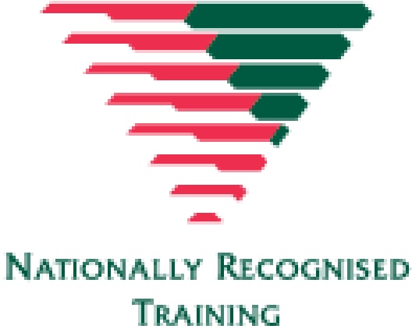
For more information on this course,
contact the Training Office in your area
1300 ST JOHN (1300 785 646) WWW.STJOHN.ORG.AU

