Provide Pain Management

This course covers the proper administration of paracetamol and methoxyflurane to relieve pain. It includes information about the use, storage, and documentation of administration as well as ongoing monitoring of the casualty.
PRE-REQUISITE UNIT
Participants are required to undertake or present evidence for HLTAID011 Provide First Aid prior to commencing PUAEME008 Provide Pain Management.
COURSE DURATION
St John offers the following options:
- Half day face to face workshop: This is a full face to face course and participants are required to attend the full session.
- Assessment only: This course is for those who are confident in their skills and only want to complete the assessment.
CERTIFICATE
On successful completion of this course you will be issued a statement of attainment in:
- PUAEME008 Provide Pain Management
COURSE OUTLINE
This course covers:
- Revision of provide first aid
- Storage and documentation
- Pain management
- Analgesia
ASSESSMENT METHODS
A successful outcome for this statement of attainment will be determined by a range of different methods including written assessment, observation of simulated and practical activities etc.
LOCATIONS
St John delivers first aid courses nationally and across many locations in Australia. Choose the location to suit your needs.
- PUBLIC (at a venue near you)
- CUSTOMISED (on-site consultation)
- ONSITE (at a venue of your choice)
- ONLINE (training delivered online from our e-Learning platform)

DELIVERY BY ST JOHN’S RTO PARTNERS
St John Ambulance Australia’s courses are delivered by way of partnership agreements (e.g. with State or Territory St John Ambulance organisations). Our partners are authorised to deliver training on behalf of St John Ambulance Australia Ltd. (TOID 88041). Contact details for our partner organisations are available from www.stjohn.org.au or call 1300 ST JOHN.
PARTICIPANT’S HANDBOOK
Download the Participant’s Handbook from www.stjohn.org.au for more information about completing a course with St John Ambulance Australia. This includes information about complaints, appeals and privacy information.
We actively tailor training to meet the needs of people from diverse backgrounds and abilities and encourage all to apply.
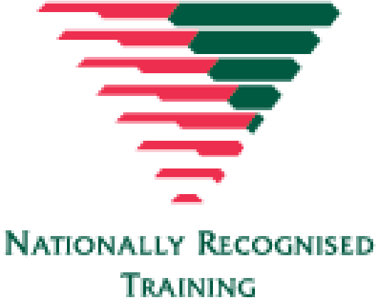
For more information on this course,
contact the Training Office in your area
1300 ST JOHN (1300 785 646) WWW.STJOHN.ORG.AU

