Anaphylaxis in the Workplace

This course is designed to give you the confidence, knowledge, and skills to recognise and manage an anaphylactic emergency including the use of the adrenaline auto-injector. This course applies to a wide range of settings where emergencies involving allergic reaction may occur.
The purpose of 22578VIC Course in First Aid Management of Anaphylaxis is to provide nationally recognised training for individuals who have responsibility for others in the workplace (adults and/or children) who have been diagnosed as being at risk of anaphylaxis. The aim of the course is to provide participants with the necessary skills and knowledge to develop an anaphylaxis management strategy and provide anaphylaxis related first aid interventions in the workplace.

PARTICIPANT COHORT
Participants generally include first aiders, teachers or childcare workers who require skills in managing an anaphylaxis emergency. Some participants may attend the course to meet workplace requirements. The target audience for this course includes, but is not limited to:
- Early childhood educators and teachers (primary/secondary)
- Sports coaches and Outdoor recreation guides/leaders
- Industry/workplace first aiders
- Residential aged care and Disability support workers

PREREQUISITES
There are no mandatory entry requirements for 22578VIC Course in First Aid Management of Anaphylaxis.
COURSE DURATION
St John offers the following delivery options:
- 4 hours face to face workshop: This is full face to face course and participants are required to attend the full workshop.
- Assessment only: The assessment only option will particularly suit participants who regularly apply anaphylaxis skills and engage in ongoing learning about management of anaphylaxis.
CERTIFICATE
On successful completion of this course, you will be issued a statement of attainment in 22578VIC Course in First Aid Management of Anaphylaxis.
Refresher training is recommended every two (2) years according to the Project Steering Committee or as per the relevant State/Territory legislation and workplace requirement for Anaphylaxis. The existing course meets the needs of each of the following legislation and it is anticipated that the re-accredited course will meet these requirements:
- Ministerial Order 706 - Anaphylaxis Management in Victorian Schools
- Children’s Services Regulations 2009
- Education and Care Services National Regulations 2011

COURSE OUTLINE
This course covers
- Anaphylaxis and allergy overview
- Anaphylaxis signs, symptoms, and triggers
- Anaphylaxis medications and devices
- Anaphylaxis action plans
- Anaphylaxis risk management planning for the workplace
- Hands-on-practice adrenaline auto-injector administration (Epi-pen)
- Anaphylaxis first aid management

ASSESSMENT METHODS
A successful outcome for this statement of attainment will be determined by a range of different methods including written assessment, observation of simulated and practical activities etc.

LOCATIONS
St John delivers first aid courses nationally and across many locations in Australia. Choose the location to suit your needs.
- PUBLIC (at a venue near you)
- CUSTOMISED (on-site consultation)
- ONSITE (at a venue of your choice)
- ONLINE (training delivered online from our e-Learning platform)

DELIVERY BY ST JOHN’S RTO PARTNERS
St John Ambulance Australia’s courses are delivered by way of partnership agreements (e.g. with State or Territory St John Ambulance organisations). Our partners are authorised to deliver training on behalf of St John Ambulance Australia Ltd. (TOID 88041). Contact details for our partner organisations are available from www.stjohn.org.au or call 1300 ST JOHN.

PARTICIPANT’S HANDBOOK
Download the Participant’s Handbook from www.stjohn.org.au for more information about completing a course with St John Ambulance Australia. This includes information about complaints, appeals and privacy information.
We actively tailor training to meet the needs of people from diverse backgrounds and abilities and encourage all to apply.
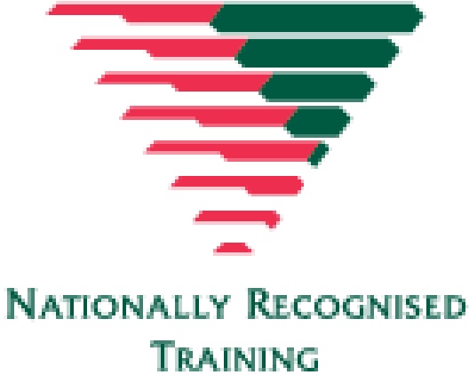
For more information on this course,
contact the Training Office in your area
1300 ST JOHN (1300 785 646) WWW.STJOHN.ORG.AU

